1. Introduction to Machine Learning
What is Machine Learning?
Machine Learning (ML) is a branch of Artificial Intelligence (AI) that enables computers to learn patterns from data and use those patterns to make predictions or decisions without being explicitly programmed with every rule.
Traditional programming vs. Machine Learning
Traditional programming
Data + Rules → Output
Example: A programmer writes a rule that a product costs 10% more after adding a 10% markup.
Machine Learning
Data + Correct Examples → Learned Model
New Data + Learned Model → Prediction
Example: A model learns from past house prices and predicts the price of a new house.
Real-world applications
Application | What ML does
Email spam detection | Classifies emails as spam or not spam
House price prediction | Predicts a property's price
Customer churn | Predicts whether a customer may leave
Recommendation systems | Suggests products or movies
Image recognition | Identifies objects in images
Fraud detection | Identifies suspicious transactions
2. Types of Machine Learning
Machine Learning is commonly divided into four broad categories.

1. Supervised Learning
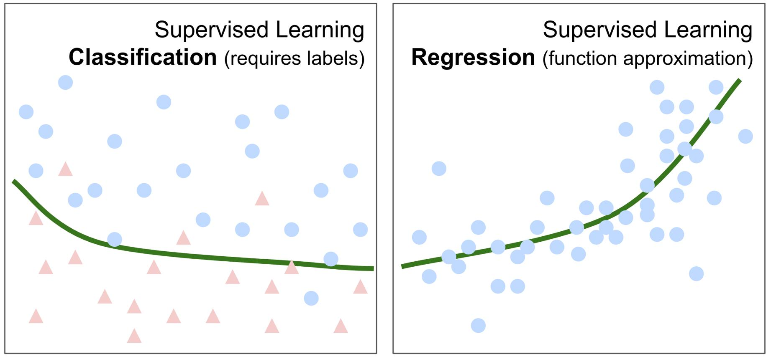
Learns from labeled data, where the correct answer is already known.
Examples: House price prediction and spam classification.

2. Unsupervised Learning
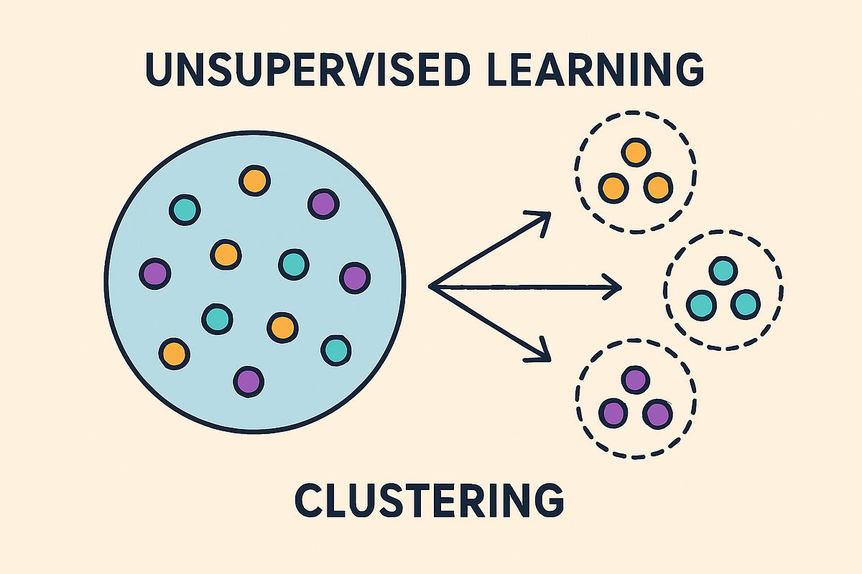
Finds patterns or structures in data without labeled answers.
Examples: Customer segmentation and grouping similar documents.
3. Reinforcement Learning

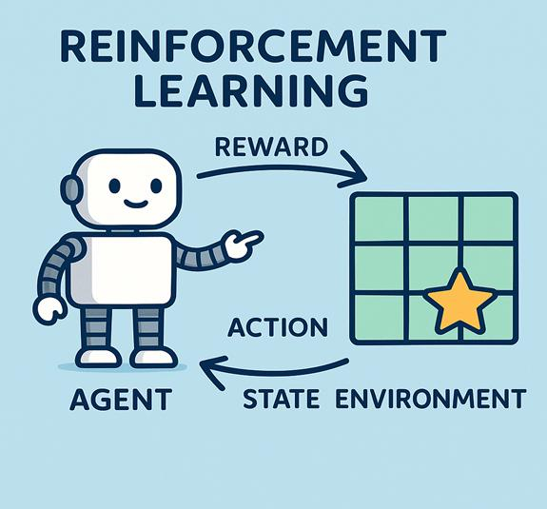
An agent learns by interacting with an environment and receiving rewards or penalties.
Examples: Game-playing agents and robot navigation.

4. Self-Supervised Learning
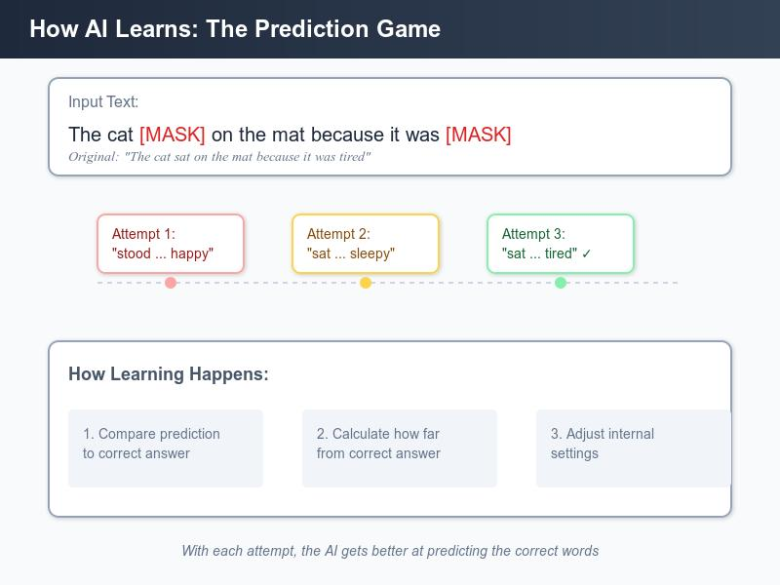
Creates learning targets from the data itself, rather than relying on manually labeled examples.
Examples: Predicting missing words in text and learning image representations.
Quick comparison
Type | Training data | Main goal

Supervised | Labeled | Predict known targets

Unsupervised | Unlabeled | Discover patterns

Reinforcement | Rewards and interactions | Learn actions

Self-supervised | Data-generated targets | Learn useful representations
3. Classical Machine Learning Pipeline
A Machine Learning pipeline is a sequence of steps used to turn raw data into a trained model that can make useful predictions.
1. Data Collection
Gather raw data from relevant sources.
2. Data Preprocessing
Clean, transform, and prepare data.
3. Feature Crafting / Engineering
Select or create useful input variables.
4. Modeling and Training
Choose an algorithm and learn model parameters.
5. Testing and Evaluation
Measure performance on unseen data.
6. Deployment
Make the model available for real-world predictions.
The pipeline is iterative: if evaluation reveals problems, you may return to preprocessing, feature engineering, or modeling.
Step 1: Data collection
Data collection means gathering the information needed to solve a problem.
Example: House price prediction
You collect historical house data:
Area (sq. ft.) | Bedrooms | Price (PKR)
1,000 | 2 | 8,000,000
1,500 | 3 | 12,000,000
2,000 | 3 | 16,000,000
2,500 | 4 | 20,000,000
Sources may include databases, APIs, CSV files, sensors, or surveys.

Step 2: Data preprocessing
Raw data often contains errors and inconsistencies.
Common preprocessing tasks:
- Missing values: Fill them or remove affected rows when appropriate.
- Duplicate records: Identify and remove duplicates.
- Incorrect values: Correct invalid entries.
- Encoding: Convert categorical values into numerical representations.
- Scaling: Bring features to comparable scales when useful.
- Data splitting: Separate data into training, validation, and test sets.
Example:
Python
Run
import pandas as pd

df = pd.DataFrame({
"area": [1000, 1500, None, 2500],
"price": [8_000_000, 12_000_000, 16_000_000, 20_000_000]
})

df["area"] = df["area"].fillna(df["area"].median())

print(df)
The missing area is replaced with the median of the available area values.
Step 3: Feature crafting / engineering
A feature is an input variable used by a model to make predictions.
Feature engineering means selecting, transforming, or creating features that help the model learn useful patterns.
Example:

Suppose a dataset contains:
- House area
- Number of bedrooms
- House prices
- Number of bathrooms
- Construction year
You could create a new feature:
Python
Run
df["price_per_sqft"] = df["price"] / df["area"]
Other examples:
- Extracting the month from a date.
- Calculating a customer's total spending.
- Converting text into numerical features.
- Creating an age feature from a birth date.
Important: Features should be created using information that would actually be available at prediction time.
Step 4: Modeling
Modeling means selecting a suitable algorithm and training it on the prepared data.
Problem | Possible model
Predict house price | Linear Regression
Predict customer churn | Logistic Regression, Decision Tree
Group customers | K-Means
Recognize images | CNN or other neural networks
Training adjusts the model's parameters so that its predictions fit the training data.
Step 5: Testing and evaluation
Evaluation measures how well the model performs on data it did not use for training.
Typical data split:
- Training set: Used to learn model parameters.
- Validation set: Used to tune settings and compare models.
- Test set: Used for final evaluation.
Common metrics:
Task | Metrics
Regression | MAE, MSE, RMSE, $R^{2}$
Classification | Accuracy, Precision, Recall, F1-score
Step 6: Deployment
Deployment means making a trained model available for practical use.
For example, a trained house-price model could be integrated into a web application:
- User enters the house area and other details.
- The application sends the data to a model API.
- The model predicts the price.
- The application displays the result.
After deployment, the model should be monitored for performance changes and data drift.
4. Supervised Machine Learning
What is supervised learning?
Supervised learning is a type of ML in which a model learns from examples containing both input features and their correct target values.
A supervised dataset can be represented as:
D={(xi,yi)}i=1mD = \{(x_i,y_i)\}_{i=1}^{m}D={(xi,yi)}i=1m
Where:
- xix_ixi = input features for the iii-th example.
- yiy_iyi = correct target value.
- mmm = number of training examples.

Example
Study hours (X) | Exam score (Y)
1 | 40
2 | 50
3 | 60
4 | 70
The model learns a relationship between study hours and exam scores, then predicts a score for a new number of study hours.

5. Regression and Classification Problems
Supervised learning has two major problem types: regression and classification.
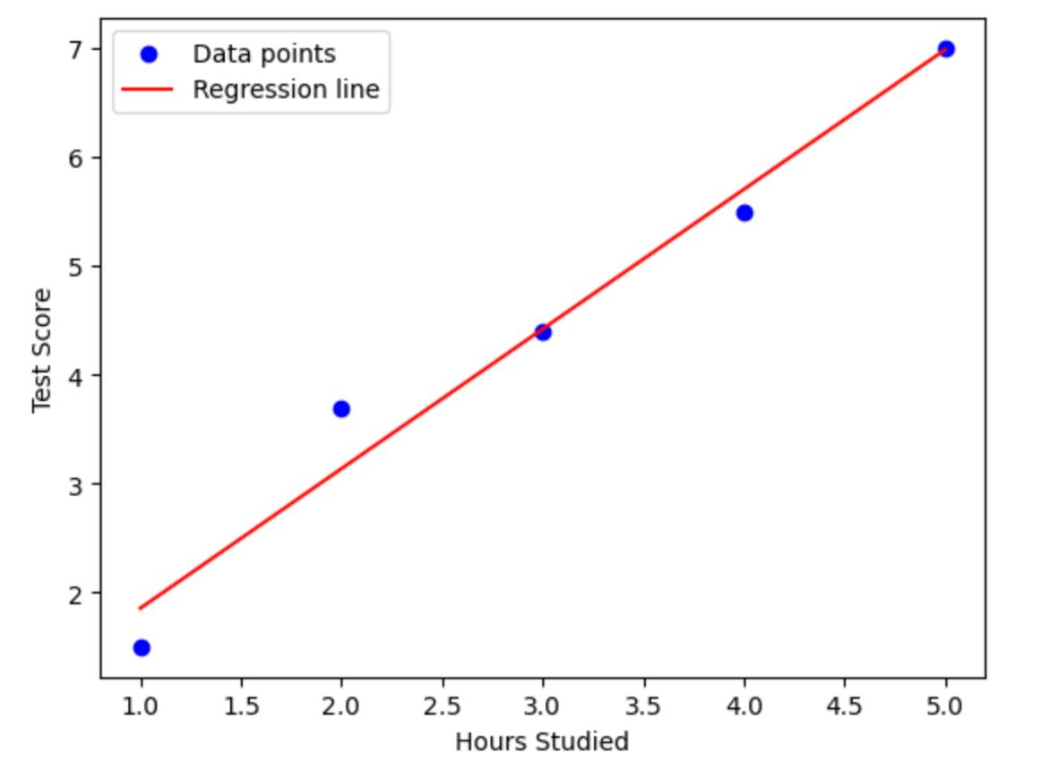
A. Regression
Regression predicts a continuous numerical value.
Examples:
- House price: PKR 15,000,000
- Temperature: 32.5°C
- Monthly sales: 250,000
- Salary: PKR 180,000
A simple regression model:
y^=wx+b\hat{y}=wx+by^=wx+b
Here, y^\hat yy^ is the predicted value.
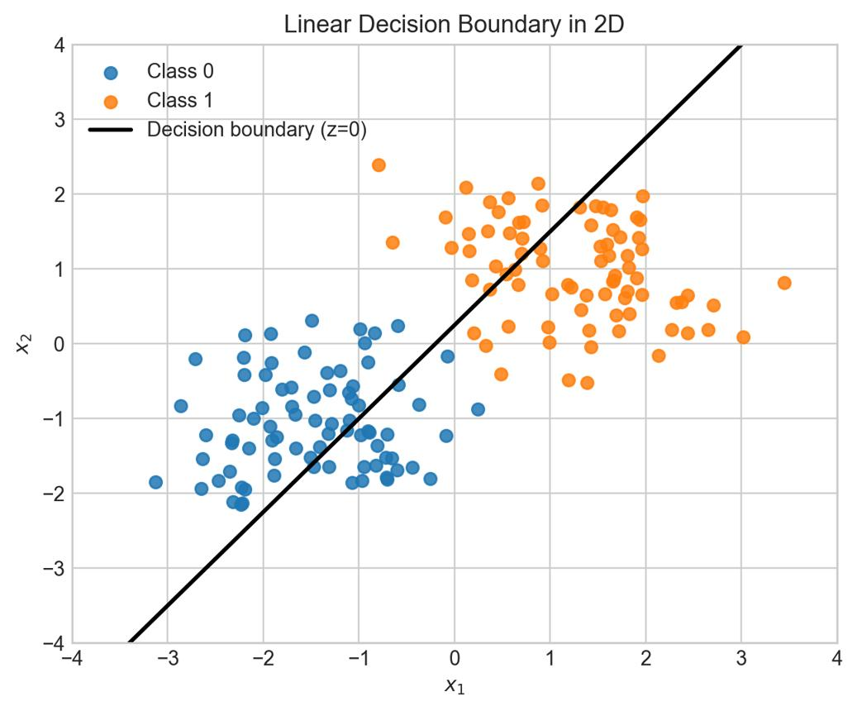
B. Classification
Classification predicts a category or class label.
Examples:
- Email: Spam or Not Spam
- Transaction: Fraud or Legitimate
- Customer: Churn or No Churn
- Image: Cat, Dog, or Bird
A classification model may output a probability and then assign a class using a decision threshold.
Main difference
Regression | Classification
Predicts numerical values | Predicts categories
Example: House price | Example: Spam detection
MAE, MSE, RMSE, $R^{2}$ | Accuracy, Precision, Recall, F1

6. Components of Supervised Machine Learning
Four important components are labeled data, hypothesis, cost function, and optimizer.
6.1 Labeled data
Labeled data consists of input features paired with the correct answers.
Example:
X: Area | Y: House price
1,000 | 8,000,000
1,500 | 12,000,000
2,000 | 16,000,000

Here, area is the feature, and house price is the label or target.
The model uses these examples to learn the relationship between area and price.
6.2 Hypothesis
A hypothesis is the mathematical function the model uses to generate predictions.
For univariate linear regression:
y^=wx+b\boxed{\hat y = wx+b}y^=wx+b
Where:
- xxx = input feature.
- www = weight or slope.
- bbb = bias or intercept.
- y^\hat yy^ = predicted output.
Example:
y^=5x+10\hat y=5x+10y^=5x+10
If x=4x=4x=4:
y^=5(4)+10=30\hat y=5(4)+10=30y^=5(4)+10=30
The predicted output is 30.
6.3 Cost function
A cost function measures how far the model's predictions are from the correct answers.
For linear regression, a common choice is Mean Squared Error (MSE).
J(w,b)=1m∑i=1m(y^i−yi)2J(w,b)=\frac{1}{m}\sum_{i=1}^{m} (\hat y_i-y_i)^2J(w,b)=m1i=1∑m(y^i−yi)2
Some implementations use half the MSE:
J(w,b)=12m∑i=1m(wxi+b−yi)2J(w,b)=\frac{1}{2m}\sum_{i=1}^{m} (wx_i+b-y_i)^2J(w,b)=2m1i=1∑m(wxi+b−yi)2
The factor 1/21/21/2 makes the gradient formulas simpler. Both cost functions have the same minimizing parameters.
A lower cost generally means the predictions are closer to the training targets.
6.4 Optimizer
An optimizer updates the model's parameters to reduce the cost function.
Examples:
- Gradient Descent
- Stochastic Gradient Descent (SGD)
- Adam
For linear regression, Gradient Descent repeatedly adjusts weights and biases` in the direction that reduces the cost.
7. Univariate Linear Regression
What does univariate mean?
- Uni means one.
- Variate refers to a variable.
So, univariate linear regression uses one input feature to predict one numerical output.
Example: Predicting exam scores
Suppose we want to predict a student's exam score based on study hours.
Suppose we want to predict a student's exam score based on study hours.
Study hours (X) | Exam score (Y)
1 | 2
2 | 4
3 | 6
4 | 8
5 | 10
The relationship is:
y=2xy=2xy=2x
If a student studies for 6 hours, the predicted score is:
y^=2(6)=12\hat y=2(6)=12y^=2(6)=12
This is a simple, idealized dataset where every point lies exactly on a straight line.
The linear regression equation
The hypothesis is:
y^=wx+b\boxed{\hat y=wx+b}y^=wx+b
Symbol | Meaning
$$x$$ | Input feature
$$\hat{y}$$ | Predicted output
$$w$$ | Weight or slope
$$b$$ | Bias or intercept
The goal is to find values of weights and biases that make the predictions close to the actual target values.
8. Gradient Descent in Linear Regression
What is Gradient Descent?
Gradient Descent is an optimization algorithm that adjusts model parameters to reduce the cost function.
Imagine a ball rolling down a hill. It moves in the direction of decreasing height until it reaches a low point.
In Machine Learning:
- Height represents the cost.
- The position represents the parameters www and bbb.
- The slope tells us which direction increases the cost.
- Gradient Descent moves in the opposite direction to reduce the cost.
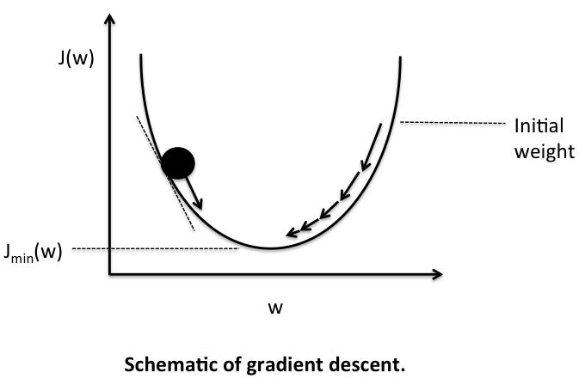
8.1 Cost function
We use the following cost function for linear regression:
J(w,b)=12m∑i=1m(wxi+b−yi)2J(w,b)=\frac{1}{2m}\sum_{i=1}^{m} (wx_i+b-y_i)^2J(w,b)=2m1i=1∑m(wxi+b−yi)2
Where:
- mmm = number of training examples.
- xix_ixi = input of example iii.
- yiy_iyi = actual target.
- wxi+bwx_i+bwxi+b = predicted target.
The objective is to minimize J(w,b)J(w,b)J(w,b).
8.2 What is a gradient?
A gradient tells us how the cost changes when a parameter changes.
We need two partial derivatives:
∂J∂w=1m∑i=1m(wxi+b−yi)xi\frac{\partial J}{\partial w} =\frac{1}{m}\sum_{i=1}^{m} (wx_i+b-y_i)x_i∂w∂J=m1i=1∑m(wxi+b−yi)xi
∂J∂b=1m∑i=1m(wxi+b−yi)\frac{\partial J}{\partial b} =\frac{1}{m}\sum_{i=1}^{m} (wx_i+b-y_i)∂b∂J=m1i=1∑m(wxi+b−yi)
These derivatives tell us how to adjust the weight and bias.
8.3 Parameter update rules
The Gradient Descent update equations are:
w:=w−α∂J∂w\boxed{ w:=w-\alpha\frac{\partial J}{\partial w} }w:=w−α∂w∂J
b:=b−α∂J∂b\boxed{ b:=b-\alpha\frac{\partial J}{\partial b} }b:=b−α∂b∂J
Here, α\alphaα is the learning rate.
What is the learning rate?
The learning rate controls how large each parameter update is.
- Too small: Training may take a long time.
- Too large: Training may overshoot the minimum or fail to converge.
- Appropriate: The cost generally decreases toward a minimum.
8.4 Complete Gradient Descent process
- Initialize www and bbb, often to zero.
- Calculate predictions using y^=wx+b\hat y=wx+by^=wx+b.
- Calculate the cost.
- Calculate the gradients for www and bbb.
- Update both parameters using the learning rate.
- Repeat for a specified number of iterations or until a stopping condition is reached.
9. Univariate Linear Regression with Gradient Descent — Without Vectorization
In this implementation, we use ordinary Python loops to process each training example individually.
Example dataset
We will use:
Python
Run
X = [1, 2, 3, 4, 5]
y = [2, 4, 6, 8, 10]
The expected relationship is:
y=2xy=2xy=2x
We will start with w=0w=0w=0 and b=0b=0b=0, then use Gradient Descent to learn the parameters.
Python implementation
Python
Run
# Training data
X = [1, 2, 3, 4, 5]
y = [2, 4, 6, 8, 10]

# Hyperparameters
w = 0.0
b = 0.0
learning_rate = 0.01
epochs = 1000

m = len(X)

for epoch in range(epochs):

# Initialize gradients
dw = 0.0
db = 0.0

# Calculate gradients using a loop
for i in range(m):
y_pred = w * X[i] + b
error = y_pred - y[i]

dw += error * X[i]
db += error

# Average gradients
dw = dw / m
db = db / m

# Update parameters
w = w - learning_rate * dw
b = b - learning_rate * db

print("Weight:", w)
print("Bias:", b)

# Prediction
new_x = 6
prediction = w * new_x + b

print("Predicted value:", prediction)
Explanation of the code
1. Initialize parameters
Python
Run
w = 0.0
b = 0.0
Initially, the model predicts zero for every input.
2. Calculate the prediction
Python
Run
y_pred = w * X[i] + b
For the first example, x=1x=1x=1:
y^=0(1)+0=0\hat y=0(1)+0=0y^=0(1)+0=0
The actual value is 2, so the error is:
e=y^−y=0−2=−2e=\hat y-y=0-2=-2e=y^−y=0−2=−2
3. Accumulate the gradients
Python
Run
dw += error * X[i]
db += error
The weight gradient uses the error multiplied by the input. The bias gradient uses the error directly.
4. Average the gradients
Python
Run
dw = dw / m
db = db / m
This calculates the mean gradient over all training examples.
5. Update parameters
Python
Run
w = w - learning_rate * dw
b = b - learning_rate * db
The parameters are updated in the direction that reduces the cost.
6. Predict a new value
Python
Run
prediction = w * 6 + b
After training, the model should predict a value close to 12.
10. Univariate Linear Regression with Gradient Descent — With Vectorization
What is vectorization?
Vectorization means performing operations on entire arrays or vectors instead of explicitly looping through each element in Python.
NumPy supports array operations and matrix multiplication, which can make numerical computations more concise and often more efficient.

NumPy v2.5 Manual
+1
For example, without vectorization:
Python
Run
X = [1, 2, 3, 4, 5]

squared = []

for x in X:
squared.append(x ** 2)

print(squared)
With NumPy array operations:
Python
Run
import numpy as np

X = np.array([1, 2, 3, 4, 5])

squared = X ** 2

print(squared)
Output:
[ 1 4 9 16 25]
NumPy applies the operation to the entire array without requiring an explicit Python loop.
Important: np.vectorize() is primarily a convenience wrapper and is essentially a loop. It does not generally provide the performance benefits of native NumPy array operations.
NumPy v2.5 Manual
10.1 Vectorized Gradient Descent equations
Let the input and target values be NumPy arrays:
X=$x1,x2,…,xm$X=$x_1,x_2,ldots,x_m$X=$x1\text{​},x2\text{​},…,xm\text{​}$
y=$y1,y2,…,ym$y=$y_1,y_2,ldots,y_m$y=$y1\text{​},y2\text{​},…,ym\text{​}$
Predictions for all examples:
y^=wX+b\hat y=wX+by^=wX+b
Errors:
e=y^−ye=\hat y-ye=y^−y
Weight gradient:
dw=1m∑i=1meixi\boxed{ dw=\frac{1}{m}\sum_{i=1}^{m}e_ix_i }dw=m1i=1∑meixi
Bias gradient:
db=1m∑i=1mei\boxed{ db=\frac{1}{m}\sum_{i=1}^{m}e_i }db=m1i=1∑mei
The sum for the weight gradient can be computed with np.sum(errors * X).
10.2 Python implementation using NumPy
Python
Run
import numpy as np

# Training data
X = np.array([1, 2, 3, 4, 5], dtype=float)
y = np.array([2, 4, 6, 8, 10], dtype=float)

# Hyperparameters
w = 0.0
b = 0.0
learning_rate = 0.01
epochs = 1000

m = len(X)

for epoch in range(epochs):

# Vectorized predictions
y_pred = w * X + b

# Calculate errors for all examples
errors = y_pred - y

# Vectorized gradient calculations
dw = np.sum(errors * X) / m
db = np.sum(errors) / m

# Update parameters
w = w - learning_rate * dw
b = b - learning_rate * db

print("Weight:", w)
print("Bias:", b)

# Prediction
new_x = 6
prediction = w * new_x + b

print("Predicted value:", prediction)
Explanation
Code | Meaning
w * X + b | Calculates predictions for all inputs
y_pred - y | Calculates all prediction errors
errors * X | Multiplies each error by its input
np.sum(errors * X) / m | Calculates the average weight gradient
np.sum(errors) / m | Calculates the average bias gradient
The main difference is that the inner Python loop has been replaced with array operations.
11. Without Vectorization vs. With Vectorization
Here is a direct comparison of the two implementations.
Feature | Without vectorization | With vectorization
Data structure | Python lists | NumPy arrays
Gradient calculation | Explicit for loop | Array operations
Code length | More verbose | More concise
Performance | Python loop overhead | Often faster for large arrays
Learning value | Helps understand each calculation | Helps understand numerical computing
Both implementations use the same mathematical algorithm and should learn similar parameter values when initialized identically and trained with the same learning rate and number of iterations.
12. Understanding Gradient Descent Through One Iteration
Let's manually calculate the first iteration using the dataset:
X=$1,2,3$,y=$2,4,6$X=$1,2,3$,\qquad y=$2,4,6$X=$1,2,3$,y=$2,4,6$
Assume:
w=0,b=0,α=0.01w=0,\quad b=0,\quad \alpha=0.01w=0,b=0,α=0.01
Step 1: Calculate predictions
y^=$0,0,0$\hat y=$0,0,0$y^=$0,0,0$
Step 2: Calculate errors
e=y^−y=$-2,-4,-6$e=\hat y-y=$-2,-4,-6$e=y^−y=$-2,-4,-6$
Step 3: Calculate the weight gradient
dw=(−2)(1)+(−4)(2)+(−6)(3)3dw=\frac{(-2)(1)+(-4)(2)+(-6)(3)}{3}dw=3(−2)(1)+(−4)(2)+(−6)(3)
dw=−283≈−9.3333dw=\frac{-28}{3}\approx-9.3333dw=3−28≈−9.3333
Step 4: Calculate the bias gradient
db=−2−4−63=−4db=\frac{-2-4-6}{3}=-4db=3−2−4−6=−4
Step 5: Update the parameters
w=0−0.01(−9.3333)=0.093333w=0-0.01(-9.3333)=0.093333w=0−0.01(−9.3333)=0.093333
b=0−0.01(−4)=0.04b=0-0.01(-4)=0.04b=0−0.01(−4)=0.04
After one iteration:
- New weight: approximately 0.0933
- New bias: 0.04
The parameters have moved away from zero toward values that better fit the data.
13. How to Know Whether Gradient Descent Is Working
You can calculate the cost after each iteration to see whether the model is learning.
Python
Run
import numpy as np

X = np.array([1, 2, 3, 4, 5], dtype=float)
y = np.array([2, 4, 6, 8, 10], dtype=float)

w = 0.0
b = 0.0
learning_rate = 0.01
epochs = 1000

m = len(X)

for epoch in range(epochs):

y_pred = w * X + b
errors = y_pred - y

cost = np.sum(errors ** 2) / (2 * m)

dw = np.sum(errors * X) / m
db = np.sum(errors) / m

w -= learning_rate * dw
b -= learning_rate * db

if epoch % 100 == 0:
print(f"Epoch {epoch}, Cost: {cost:.4f}")
print("Final weight:", w)
print("Final bias:", b)
As training progresses, the cost should generally decrease when the learning rate is suitable.
14. Important Terms to Remember
Term | Meaning
Feature | Input variable used for prediction
Target / Label | Correct output value
Hypothesis | Function that generates predictions
Weight | Parameter controlling the feature's contribution
Bias | Intercept added to the prediction
Cost function | Measures prediction error
Gradient | Direction and rate of change of cost
Optimizer | Updates parameters to reduce cost
Learning rate | Controls the size of parameter updates
Epoch | One complete pass through the training dataset
Vectorization | Performing operations on arrays without explicit element-by-element Python loops
15. Quick Revision
The complete learning process
- Collect and prepare labeled data.
- Choose a model, such as linear regression.
- Define a hypothesis: y^=wx+b\hat y=wx+by^=wx+b.
- Calculate the cost using prediction errors.
- Compute gradients for www and bbb.
- Update the parameters using Gradient Descent.
- Repeat until the model learns a useful relationship.
- Evaluate the model on unseen data and deploy it if appropriate.
Core Gradient Descent equations
y^=wx+b\hat y=wx+by^=wx+b
dw=1m∑(y^i−yi)xidw=\frac{1}{m}\sum(\hat y_i-y_i)x_idw=m1∑(y^i−yi)xi
db=1m∑(y^i−yi)db=\frac{1}{m}\sum(\hat y_i-y_i)db=m1∑(y^i−yi)
w:=w−αdww:=w-\alpha dww:=w−αdw
b:=b−αdbb:=b-\alpha dbb:=b−αdb
Practice questions
1. What does supervised learning require?
Only unlabeled data
Labeled training examples
Only rewards
No data
2. What does regression predict?
Only categories
Continuous numerical values
Only images
Only text
3. What is the hypothesis for univariate linear regression?
y = x²
ŷ = wx + b
y = w + b²
ŷ = x / b
4. What is the purpose of a cost function?
Collect data
Measure prediction error
Deploy a model
Encode categories
5. What does the learning rate control?
Number of features
Size of parameter updates
Number of labels
Dataset size
6. What is vectorization?
Using only Python loops
Performing array operations without explicit element-wise Python loops
Deleting data
Changing labels
Check answers
Further reading
- NumPy official documentation
— array operations and numerical computing.
- NumPy vectorize documentation
— how np.vectorize() works and its performance limitations.
- NumPy linear algebra documentation
— matrix multiplication and the @ operator.

